

**CS-114 - Fundamental of Programing**

**Lab Manual # 1**

**Home Task**

Submitted To: Muhammad Affan

Submitted By: Shahzaib Murtaza (466034)

Section: B

Q#1) Write a C++ code to calculate a factorial of 6.

#include <iostream>

using namespace std;

int main(){

cout<< "6!=" << 6*5*4*3*2*1;

return 0;

}

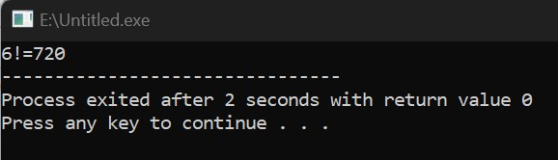

Q#2) Write a C++ program to calculate distance between two points. The values of coordinates should be input by user.



#include <iostream>

using namespace std;

int main(){

double d , x1 , x2 , y1 , y2;

cout << "Enter x1=";

cin >> x1;

cout << "Enter x2=";

cin >> x2;

cout << "Enter y1=";

cin >> y1;

cout << "Enter y2=";

cin >> y2;

d=(x2-x1)*(x2-x1)+(y2-y1)*(y2-y1);

cout << "d=" <<d;

return 0;

}

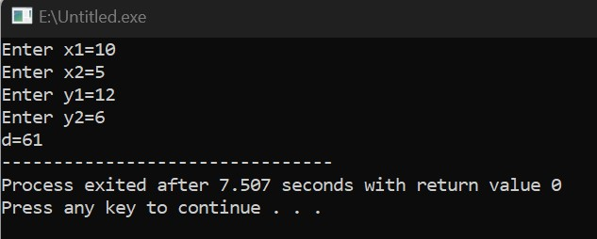

Q#3) Write a code in C++ to take length from user in centimeter and convert it into meter and kilometer.

#include <iostream>

using namespace std;

int main(){

double l,m,km;

double result;

cout << "Enter length in cm=";

cin >> l;

m= l/100;

km=l/100000;

cout << "Metre=" <<m <<endl;

cout << "Kilometre="<<km <<endl;

return 0;

}

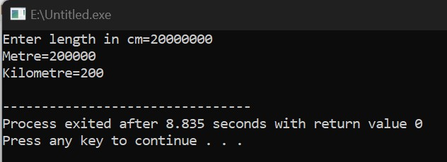

Q#4) Write a code in C++ that takes values of a and b from the user and displays result of polynomial

#include <iostream>

using namespace std;

int main(){

double x ,a , b;

cout << "Enter a=";

cin >> a;

cout << "Enter b=";

cin >> b;

x=a*a + 2*a*b + b*b ;

cout << x;

return 0;

}

